REGISTRATION FORM

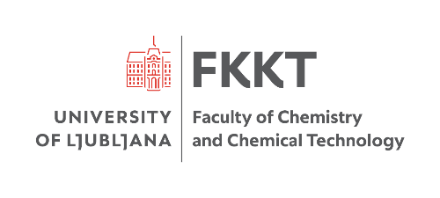   | The 30th Young Investigators' Seminar on Analytical Chemistry (YISAC 2025)  30th June – 3rd July 2025, Ljubljana, Slovenia

Please provide us with the following information:

1) | Name
2) | Surname
3) | Status | [ ] MSc student  [ ] PhD student  [ ] Supervisor
4) | Affiliation
5) | Title of presentation
6) | The scientific trend of presentation  (Chromatographic methods, Spectroscopy, Electrochemical sensors and methods, Environmental analysis, etc.)
7) | Excursion  On the last day of the conference (July 3rd, 2024) there will be an excursion for the conference participants. | Are you interested to participate in the excursion?  [ ] Yes  [ ] No
8) | Other requirements*  Please do not hesitate to write any special request/desire related to your stay in Ljubljana (for example: for food (special menu, vegan, vegetarian), accommodation, etc.).

The filled registration form should be sent to: yisac2025@fkkt.uni-lj.si

